**MANAV RACHNA UNIVERSITY, FARIDABAD**

**Department of Computer Science and Technology**

# Course: B.Tech. CSE Semester: III

**Subject: Object Oriented Programming using Java (CSH201B-T&P)**

***Lab: 02*** *Class & Member Function*

***Objective:*** *To learn concepts of OOP*

***Course Outcomes:***

**CSH201B.1:** To impart **understanding** of basic programming concepts in Java language.

***Blooms Taxonomy Level****: BT1, BT2, BT3*

Q1. Write a java program to design a point class with all the member functions as discussed in the class.

Explain the significance of this keyword.

package Point.java;

public class Point {

private int x;

private int y;

public Point(int x, int y) {

this.x = x;

this.y = y;

}

public int getX() {

return x;

}

public void setX(int x) {

this.x = x;

}

public int getY() {

return y;

}

public void setY(int y) {

this.y = y;

}

public void move(int dx, int dy) {

x += dx;

y += dy;

}

public double distance(Point other) {

int dx = x - other.x;

int dy = y - other.y;

return Math.sqrt(dx * dx + dy * dy);

}

}

package Point.java;

public class Main {

public static void main(String[] args) {

// create two Point objects

Point p1 = new Point(0, 0);

Point p2 = new Point(3, 4);

p1.move(2, 2);

// print the new coordinates of the first point

System.out.println("p1: (" + p1.getX() + ", " + p1.getY() + ")");

// calculate the distance between the two points

double distance = p1.distance(p2);

// print the distance

System.out.println("Distance between p1 and p2: " + distance);

}

}

* This Point class has two private fields, x and y, which represent the x and y coordinates of a point. It has a constructor that takes these coordinates as arguments, as well as getter and setter methods for each field, and two additional methods move() and distance().
* The move() method takes two integer arguments dx and dy, which represent the change in x and y coordinates respectively, and updates the point's coordinates accordingly.
* The distance() method takes another Point object as an argument and returns the distance between the current point and the given point using the Pythagorean theorem.
* In Java, this is a reference to the current object. It is often used to distinguish between class fields and method parameters with the same name.

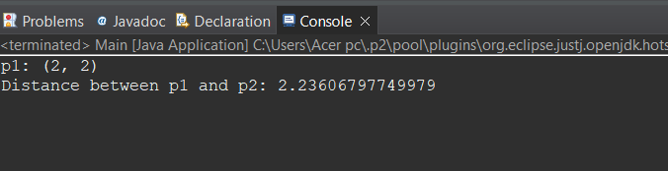

Q2. Extend the Point Class to create Circle class with necessary members functions.

package Point.java;

public class Circle extends Point {

private double radius;

public Circle(int x, int y, double radius) {

super(x, y);

this.radius = radius;

}

public double getRadius() {

return radius;

}

public void setRadius(double radius) {

this.radius = radius;

}

public double getArea() {

return Math.PI * radius * radius;

}

public double getCircumference() {

return 2 * Math.PI * radius;

}}

package Point.java;

public class Main {

public static void main(String[] args) {

// create a Circle object with center (0, 0) and radius 5

Circle circle = new Circle(0, 0, 5);

// print the circle's area and circumference

System.out.println("Circle area: " + circle.getArea());

System.out.println("Circle circumference: " + circle.getCircumference());

// move the circle's center by (2, 2)

circle.move(2, 2);

// print the new center coordinates

System.out.println("Circle center: (" + circle.getX() + ", " + circle.getY() + ")");

}

}

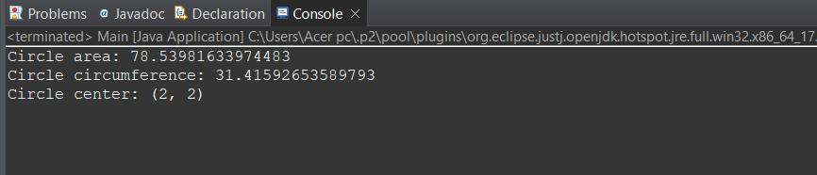

Link to install Eclipse IDE & get started with Java:

How To Setup Eclipse IDE On Windows? | Install Eclipse IDE with Java on Windows | Edureka https://[www.youtube.com/watch?v=C7_jqOTgMT0](http://www.youtube.com/watch?v=C7_jqOTgMT0)